28.51: a)

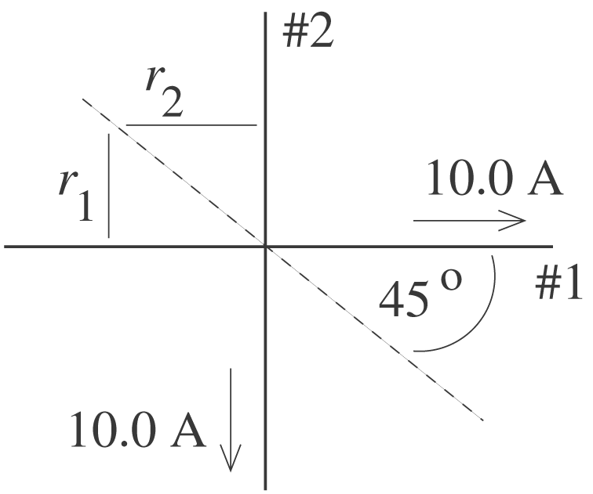 Along the dashed line, 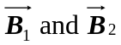 are in opposite directions.
If the line has slope 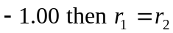 and 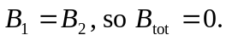
b)
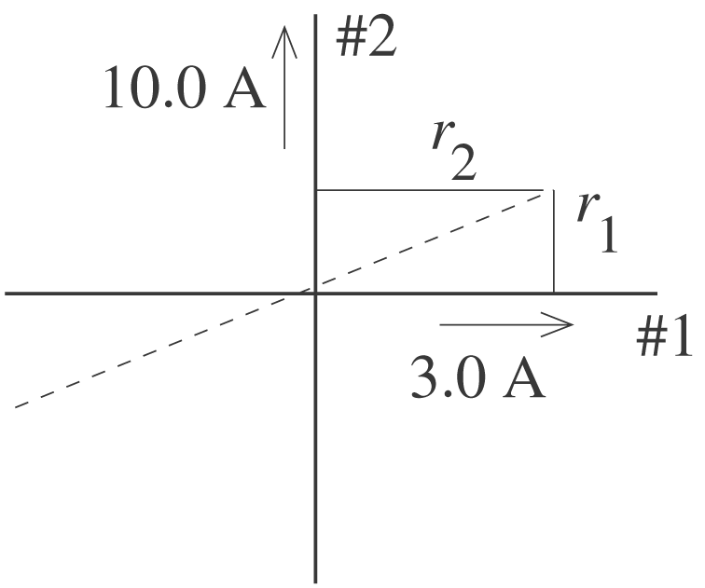
Along the dashed line, 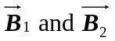 are in opposite directions.
If the line has slope 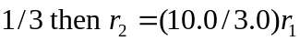
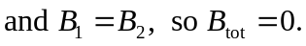

c)
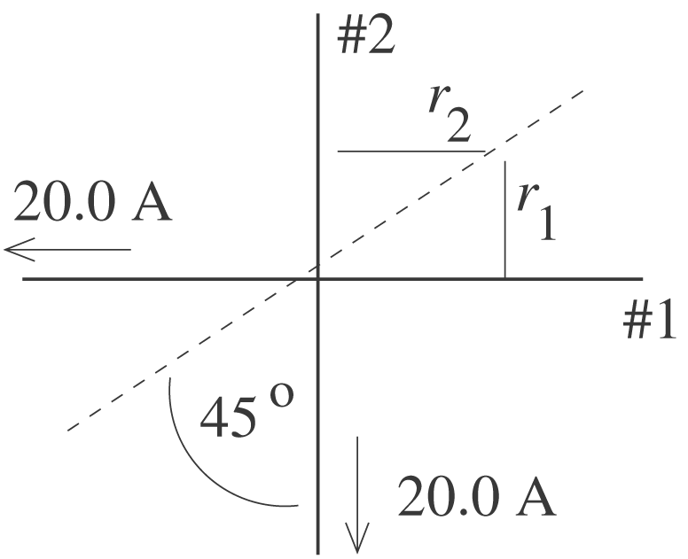
Along the dashed line, 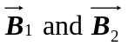 are in opposite directions.
If the line has slope + 1.00 then 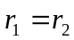 and 